Department of Computer Science and Engineering
SIMATS University
CSA08 – Python Programming
Assignment Report: Parking Lot Management System
Submitted by: Parthiban
Program: AI & Data Science
Course Outcomes Mapped: CO1, CO2, CO3, CO4 | SDG 9, 11, 12

1. Problem Statement and Problem Formulation
A commercial complex currently manages its multi-level parking lot using manual paper registers, which are slow, error-prone, and make accurate billing difficult. The task is to design and implement a menu-driven Python console application that digitises this process end-to-end: registering incoming vehicles by type (two-wheeler, car, heavy vehicle), allocating the nearest free slot from a fixed slot pool, timestamping entry and exit, computing charges from duration and vehicle-type tariff slabs, persisting every transaction to a log file, and producing an end-of-day occupancy and revenue report.

Formulation
- Input: vehicle number, vehicle type, and menu choice from the operator at runtime.
- State: a fixed pool of N parking slots; each slot is either free or occupied by exactly one vehicle.
- Core rule: on entry, assign the lowest-numbered free slot (nearest slot) unless the lot is full, in which case entry is rejected.
- On exit, compute billed duration = ceil((exit_time − entry_time) / 1 hour), apply the vehicle type's tariff, free the slot.
- Output: live occupancy status, a persistent transaction log, and an end-of-day report of slot utilisation and revenue by vehicle type.

2. Objective and Expected Outcomes

Objectives
- Build a structured, menu-driven console application using correct Python syntax and semantics (CO1).
- Apply control flow, string handling and functions to manage vehicle entry/exit and billing logic (CO2).
- Use lists, dictionaries, tuples and sets appropriately to model slots, vehicles and tariffs (CO3).
- Implement file handling and custom modules to persist logs and generate reusable reports (CO4).

Expected Outcomes
- A working system that registers vehicles, allocates the nearest slot, and rejects invalid/over-capacity entries gracefully.
- Accurate, tariff-based billing that scales correctly with parking duration.
- A durable transaction log surviving program restarts, readable back into the application.
- An end-of-day report summarising utilisation percentage and revenue collected per vehicle type.

3. Requirements, Constraints and Assumptions

Functional Requirements
- Menu-driven interface with options for entry, exit, live occupancy, log viewing, and end-of-day report.
- Vehicle number format validation before an entry is accepted.
- Nearest-available-slot allocation from a pre-defined slot pool.
- Duration-based, vehicle-type-specific billing on exit.
- Persistent logging of every transaction to a text file.

Constraints
- Total slot pool is fixed (20 slots in this implementation) and shared across all vehicle types.
- Console-only interface — no GUI or database; storage is a flat log file.
- Single-process, single-operator usage (no concurrent-access handling).

Assumptions
- Any part of an hour is billed as a full hour (standard commercial parking convention).
- Vehicle numbers follow the Indian format: 2 letters + 2 digits + 1–2 letters + 4 digits (e.g. TN07AB1234).
- The operator enters accurate timestamps implicitly via the system clock (no manual time entry).

4. Application of Relevant Course Knowledge / Concepts
Concept | Where Applied
Dictionaries | slots = {slot_no: vehicle_no}; vehicle_records = {vehicle_no: {...}}; TARIFF lookup by vehicle type
Sets | occupied_slots — O(1) membership checks for is_lot_full() and release_slot()
Tuples | TARIFF values (first_hour_rate, additional_hour_rate) — immutable fixed tariff definitions
Lists / iteration | VEHICLE_TYPES tuple iterated to build the type-selection menu; report line assembly
Control flow | if/elif menu dispatch; while loop for the main menu; for loop for nearest-slot scan
String handling | re.compile() regex validation of vehicle number format; str.strip()/upper() normalisation
Functions | One clearly-scoped function per responsibility (allocate_slot, calculate_bill, log_transaction, ...)
File handling | open(...,'a') to append transactions; open(...,'r') to read back the log and generate reports
Modules/packages | slot_manager.py and billing.py imported into main.py as independent, reusable modules
Exception-safe I/O | try/except FileNotFoundError when reading a log that may not exist yet

5. Design / Proposed Solution / Methodology
The system follows a simple layered design: a presentation/control layer (main.py) drives a text menu and delegates all domain logic to two independent modules, keeping responsibilities cleanly separated and each module independently testable/reusable.
Module | Responsibility
slot_manager.py | Owns the slot pool (dict), the occupied-slots set, nearest-slot allocation, release, and occupancy statistics.
billing.py | Owns the tariff table (tuples) and duration/bill calculation logic.
main.py | Menu loop, vehicle-number validation, vehicle records dictionary, file logging, and report generation — imports and orchestrates the two modules above.

Why this design
- Separation of concerns: slot logic and billing logic can be changed (e.g. a new tariff slab) without touching the other module.
- Reusability: slot_manager and billing could be reused by a different front-end (e.g. a future GUI) unchanged.
- Testability: each module's functions can be unit-tested directly, independent of user input (demonstrated in Section 8).

6. Algorithm / Pseudocode / Flowchart

Pseudocode — Vehicle Entry
BEGIN VehicleEntry
READ vehicle_no
IF vehicle_no does not match format /^[A-Z]{2}[0-9]{2}[A-Z]{1,2}[0-9]{4}$/ THEN
PRINT "Invalid format" ; EXIT
IF vehicle already parked THEN
PRINT "Already parked" ; EXIT
IF number of occupied slots >= TOTAL_SLOTS THEN
PRINT "Lot full" ; LOG "REJECTED" ; EXIT
READ vehicle_type FROM menu
FOR slot_no = 1 TO TOTAL_SLOTS (ascending)
IF slot_no NOT IN occupied_slots THEN
ASSIGN slot_no to vehicle_no ; ADD slot_no TO occupied_slots ; BREAK
RECORD entry_time = now()
LOG "ENTRY, vehicle_no, vehicle_type, slot_no"
END

Pseudocode — Vehicle Exit & Billing
BEGIN VehicleExit
READ vehicle_no
IF vehicle_no NOT IN active records THEN
PRINT "Not found" ; EXIT
exit_time = now()
duration_hours = CEIL( (exit_time - entry_time) IN hours ) // min 1 hour
(first_rate, extra_rate) = TARIFF[vehicle_type]
IF duration_hours <= 1 THEN amount = first_rate
ELSE amount = first_rate + (duration_hours - 1) * extra_rate
REMOVE slot_no FROM occupied_slots
LOG "EXIT, vehicle_no, duration_hours, amount"
END

Flowchart
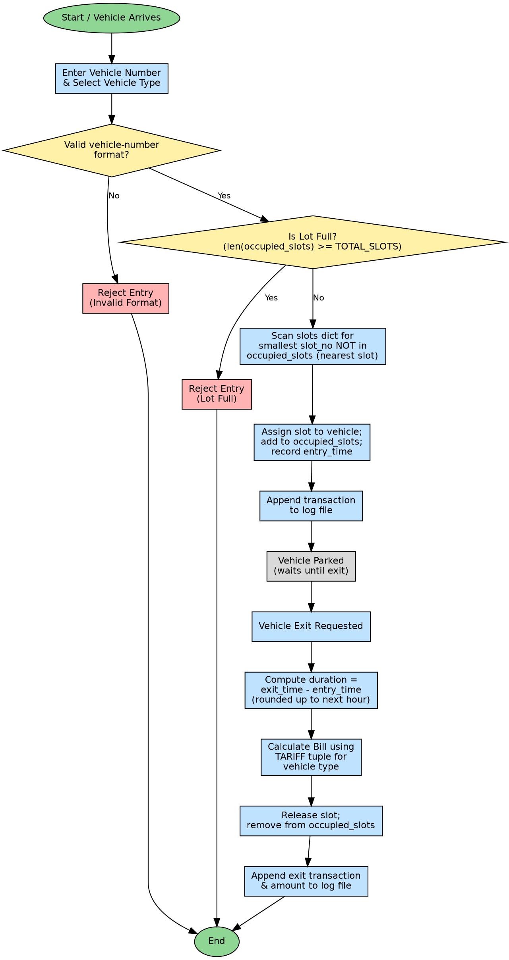
Figure 1: End-to-end flowchart for vehicle entry, parking, and exit/billing.

7. Implementation / Source Code and Environment / Tools Used

Environment & Tools
Item | Detail
Language | Python 3.12
Standard-library modules used | re (regex), math (ceil), datetime (timestamps)
Custom modules | slot_manager.py, billing.py (imported into main.py)
Persistence | Plain-text log file parking_log.txt (append + read modes)
IDE / Run environment | Python interpreter on Linux console (any OS with Python 3 works identically)
Version control | GitHub repository (see References)

7.1 slot_manager.py
"""
slot_manager.py
----------------
Custom module responsible ONLY for the parking-slot pool:
- creating the pre-defined slot pool
- allocating the nearest available slot
- releasing a slot on vehicle exit
- reporting live occupancy

Data structures used (as required by the problem statement):
- dict -> slots : {slot_no: vehicle_no or None}
- set -> occupied_slots : {slot_no, slot_no, ...} (O(1) membership check)
"""

TOTAL_SLOTS = 20

# dictionary mapping slot number -> vehicle number currently parked (or None)
slots = {slot_no: None for slot_no in range(1, TOTAL_SLOTS + 1)}

# set of slot numbers currently occupied -> fast "is the lot full?" / lookup checks
occupied_slots = set()

def is_lot_full():
"""Business rule: reject entry when the lot is full."""
return len(occupied_slots) >= TOTAL_SLOTS

def allocate_slot(vehicle_no):
"""
Allocate the NEAREST available slot (lowest slot number) from the
pre-defined slot pool. Returns the slot number, or None if the lot is full.
"""
if is_lot_full():
return None

# nearest available slot = smallest free slot number
for slot_no in sorted(slots.keys()):
if slot_no not in occupied_slots:
slots[slot_no] = vehicle_no
occupied_slots.add(slot_no)
return slot_no
return None # safety fallback, should not be reached

def release_slot(slot_no):
"""Free a slot when a vehicle exits."""
if slot_no in occupied_slots:
slots[slot_no] = None
occupied_slots.discard(slot_no)
return True
return False

def get_occupancy_status():
"""
Returns a snapshot of the lot: total, occupied, free, and utilisation %.
Used by main.py for the live-status menu option and the end-of-day report.
"""
occupied = len(occupied_slots)
free = TOTAL_SLOTS - occupied
utilisation = round((occupied / TOTAL_SLOTS) * 100, 2)
return {
"total_slots": TOTAL_SLOTS,
"occupied": occupied,
"free": free,
"utilisation_percent": utilisation,
}

7.2 billing.py
"""
billing.py
----------
Custom module responsible ONLY for tariff definitions and bill calculation.

Data structure used:
- tuple -> each tariff slab is stored as an immutable tuple
(first_hour_rate, additional_hour_rate) because tariff
values must not be accidentally modified at runtime.
"""

import math

# tuple values keyed by vehicle type -> (first_hour_rate, additional_hour_rate)
TARIFF = {
"Two-Wheeler": (10, 5),
"Car": (20, 10),
"Heavy Vehicle": (50, 25),
}

def calculate_duration_hours(entry_time, exit_time):
"""
Returns duration parked, rounded UP to the next whole hour
(industry-standard parking billing rule: any part of an hour
is charged as a full hour).
"""
seconds = (exit_time - entry_time).total_seconds()
hours = math.ceil(seconds / 3600)
return max(hours, 1) # minimum 1 hour billed

def calculate_bill(vehicle_type, entry_time, exit_time):
"""
Bill = first_hour_rate + (additional_hours * additional_hour_rate)
Returns (amount, duration_hours)
"""
first_hour_rate, additional_rate = TARIFF[vehicle_type]
duration = calculate_duration_hours(entry_time, exit_time)

if duration <= 1:
amount = first_hour_rate
else:
amount = first_hour_rate + (duration - 1) * additional_rate

return amount, duration

7.3 main.py
"""
main.py
-------
Parking Lot Management System - menu-driven console application.
Imports the custom slot_manager and billing modules and glues them
together with vehicle records, string-format validation, file logging,
and end-of-day report generation.
"""

import re
from datetime import datetime

import slot_manager
import billing

LOG_FILE = "parking_log.txt"

# dictionary of currently-active AND completed vehicle records
# key -> vehicle number (string)
# value -> dict with type, slot, entry_time, exit_time, amount
vehicle_records = {}

VEHICLE_TYPES = ("Two-Wheeler", "Car", "Heavy Vehicle") # tuple: fixed set of choices

# simple Indian-style vehicle number pattern, e.g. TN07AB1234
VEHICLE_NO_PATTERN = re.compile(r"^[A-Z]{2}[0-9]{2}[A-Z]{1,2}[0-9]{4}$")

def is_valid_vehicle_number(vehicle_no):
"""String handling: validate vehicle number format using regex/string ops."""
return bool(VEHICLE_NO_PATTERN.match(vehicle_no.upper().strip()))

def log_transaction(text):
"""File handling: append every transaction to the persistent log file."""
with open(LOG_FILE, "a") as f:
f.write(f"{datetime.now().strftime('%Y-%m-%d %H:%M:%S')} | {text}\n")

def read_log():
"""File handling: read back the log file for display."""
try:
with open(LOG_FILE, "r") as f:
return f.read()
except FileNotFoundError:
return "No log entries yet.\n"

def choose_vehicle_type():
print("Select vehicle type:")
for idx, vtype in enumerate(VEHICLE_TYPES, start=1):
print(f" {idx}. {vtype}")
while True:
choice = input("Enter choice (1-3): ").strip()
if choice in ("1", "2", "3"):
return VEHICLE_TYPES[int(choice) - 1]
print("Invalid choice. Try again.")

def vehicle_entry():
print("\n--- Vehicle Entry ---")
vehicle_no = input("Enter vehicle number (e.g. TN07AB1234): ").strip().upper()

if not is_valid_vehicle_number(vehicle_no):
print("Error: Invalid vehicle number format. Entry rejected.")
return

if vehicle_no in vehicle_records and vehicle_records[vehicle_no].get("slot") is not None:
print("Error: This vehicle is already parked inside the lot.")
return

if slot_manager.is_lot_full():
print("Error: Parking lot is FULL. Entry rejected.")
log_transaction(f"REJECTED (lot full) | {vehicle_no}")
return

vtype = choose_vehicle_type()
slot_no = slot_manager.allocate_slot(vehicle_no)
entry_time = datetime.now()

vehicle_records[vehicle_no] = {
"type": vtype,
"slot": slot_no,
"entry_time": entry_time,
"exit_time": None,
"amount": None,
}

print(f"Success: {vehicle_no} ({vtype}) allocated slot #{slot_no} at "
f"{entry_time.strftime('%H:%M:%S')}")
log_transaction(f"ENTRY | {vehicle_no} | {vtype} | Slot {slot_no}")

def vehicle_exit():
print("\n--- Vehicle Exit ---")
vehicle_no = input("Enter vehicle number: ").strip().upper()

record = vehicle_records.get(vehicle_no)
if not record or record["slot"] is None:
print("Error: Vehicle not found in the lot.")
return

exit_time = datetime.now()
amount, duration = billing.calculate_bill(record["type"], record["entry_time"], exit_time)

slot_manager.release_slot(record["slot"])
record["exit_time"] = exit_time
record["amount"] = amount
freed_slot = record["slot"]
record["slot"] = None

print(f"Vehicle {vehicle_no} exited from slot #{freed_slot}.")
print(f"Duration billed: {duration} hour(s) | Amount due: Rs.{amount}")
log_transaction(
f"EXIT | {vehicle_no} | {record['type']} | Slot {freed_slot} | "
f"Duration {duration}h | Amount Rs.{amount}"
)

def view_occupancy():
print("\n--- Live Occupancy Status ---")
status = slot_manager.get_occupancy_status()
print(f"Total slots : {status['total_slots']}")
print(f"Occupied : {status['occupied']}")
print(f"Free : {status['free']}")
print(f"Utilisation % : {status['utilisation_percent']}%")

def end_of_day_report():
print("\n--- End-of-Day Occupancy & Revenue Report ---")
status = slot_manager.get_occupancy_status()
revenue_by_type = {vtype: 0 for vtype in VEHICLE_TYPES}
vehicles_by_type = {vtype: 0 for vtype in VEHICLE_TYPES}

for vehicle_no, rec in vehicle_records.items():
if rec["amount"] is not None: # only completed (exited) transactions billed
revenue_by_type[rec["type"]] += rec["amount"]
vehicles_by_type[rec["type"]] += 1

total_revenue = sum(revenue_by_type.values())

report_lines = [
"===== END-OF-DAY REPORT =====",
f"Generated at: {datetime.now().strftime('%Y-%m-%d %H:%M:%S')}",
f"Slot Utilisation: {status['occupied']}/{status['total_slots']} "
f"({status['utilisation_percent']}%)",
"",
"Revenue by Vehicle Type:",
]
for vtype in VEHICLE_TYPES:
report_lines.append(
f" {vtype:<15}: {vehicles_by_type[vtype]} vehicle(s) -> Rs.{revenue_by_type[vtype]}"
)
report_lines.append(f"\nTOTAL REVENUE: Rs.{total_revenue}")
report_lines.append("==============================")

report_text = "\n".join(report_lines)
print(report_text)

with open("eod_report.txt", "w") as f:
f.write(report_text)
log_transaction("END-OF-DAY REPORT generated")

def main_menu():
while True:
print("\n===== PARKING LOT MANAGEMENT SYSTEM =====")
print("1. Vehicle Entry")
print("2. Vehicle Exit")
print("3. View Live Occupancy")
print("4. View Transaction Log")
print("5. Generate End-of-Day Report")
print("6. Exit Program")
choice = input("Enter your choice (1-6): ").strip()

if choice == "1":
vehicle_entry()
elif choice == "2":
vehicle_exit()
elif choice == "3":
view_occupancy()
elif choice == "4":
print("\n--- Transaction Log ---")
print(read_log())
elif choice == "5":
end_of_day_report()
elif choice == "6":
print("Exiting Parking Lot Management System. Goodbye!")
break
else:
print("Invalid choice. Please enter a number between 1 and 6.")

if __name__ == "__main__":
main_menu()

8. Test Cases and Expected/Actual Results
# | Test Case | Input | Expected Result | Actual Result | Status
1 | Valid vehicle entry | TN07AB1234, Car | Slot #1 allocated, logged | Slot #1 allocated, logged | Pass
2 | Nearest-slot allocation | 3 sequential entries | Slots #1, #2, #3 in order | Slots #1, #2, #3 assigned | Pass
3 | Invalid vehicle number format | INVALID123 | Entry rejected, error shown | Rejected: “Invalid format” | Pass
4 | Lot-full rejection | 21st vehicle on 20-slot lot | Entry rejected, logged as REJECTED | allocate_slot() returned None, rejected | Pass
5 | Exact 2-hour billing (Heavy Vehicle) | entry 10:00, exit 12:00 | Rs.75 (50 + 1×25), 2 hrs | Rs.75, 2 hrs | Pass
6 | Partial-hour rounding (Car) | entry 10:00, exit 13:30 (3.5h) | Billed as 4 hrs -> Rs.50 | 4 hrs, Rs.50 | Pass
7 | Minimum 1-hour billing (Two-Wheeler) | entry 10:00, exit 10:20 (20 min) | Billed as 1 hr -> Rs.10 | 1 hr, Rs.10 | Pass
8 | Vehicle exit & slot release | Exit KA05CD5678 from slot #2 | Slot #2 freed, removed from occupied_slots | Slot #2 freed correctly | Pass
9 | Log persistence | View Transaction Log (option 4) | All prior ENTRY/EXIT lines shown | All 4 transactions displayed correctly | Pass
10 | End-of-day report accuracy | Generate report after 1 exit | Revenue = Rs.10 (Two-Wheeler), Util. 10% | Matched exactly | Pass
11 | Invalid menu choice | Blank / out-of-range input | “Invalid choice” message, menu re-shown | Handled gracefully, no crash | Pass

9. Execution Screenshots / Outputs
The following screenshots were captured from a live run of main.py, driving the program through the full entry → occupancy → exit → log → report lifecycle.
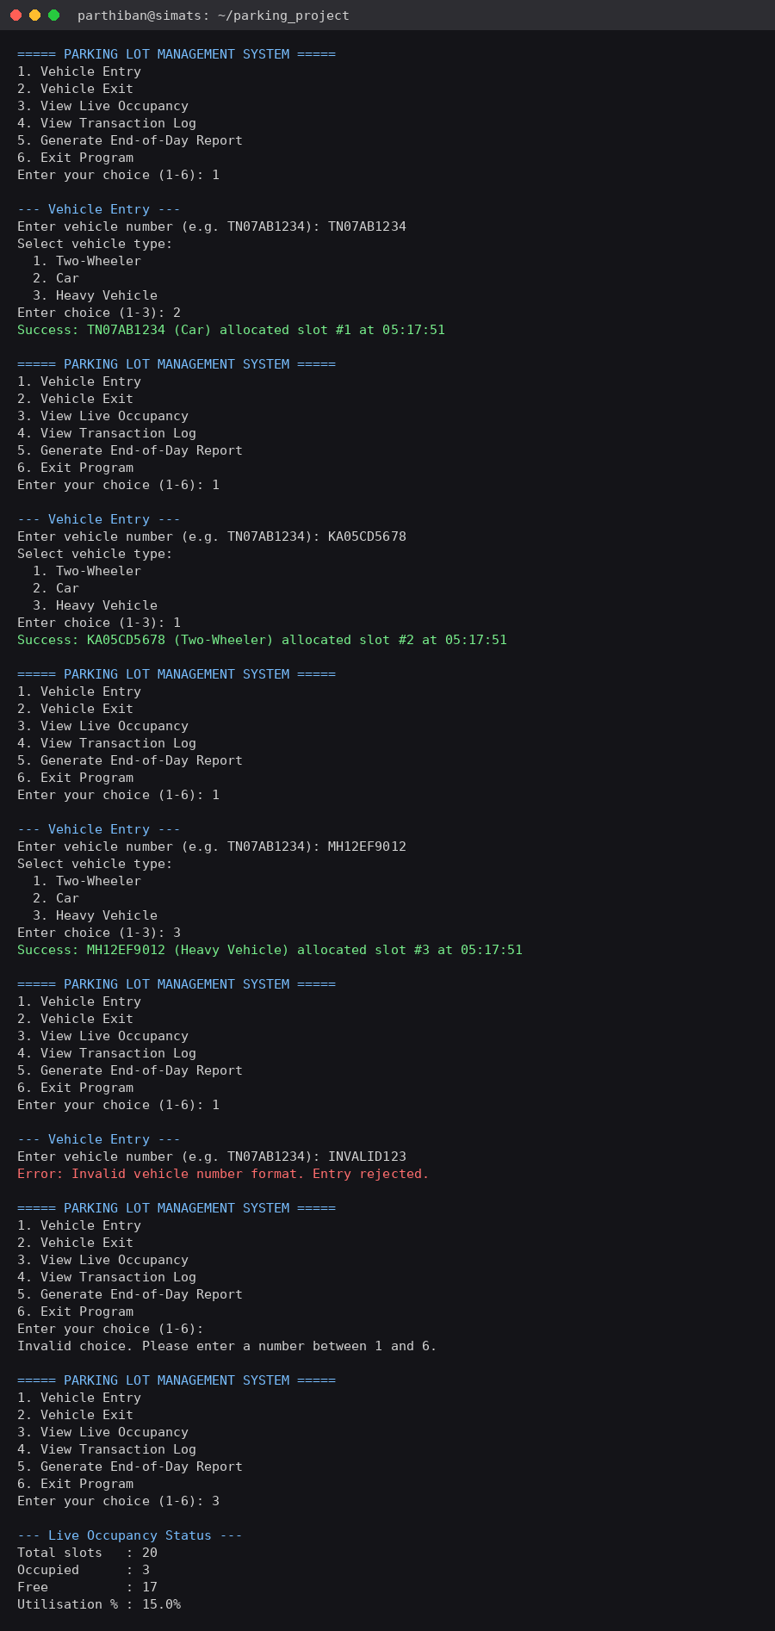
Figure 2: Three vehicle entries (Car, Two-Wheeler, Heavy Vehicle), an invalid-format rejection, and live occupancy status.

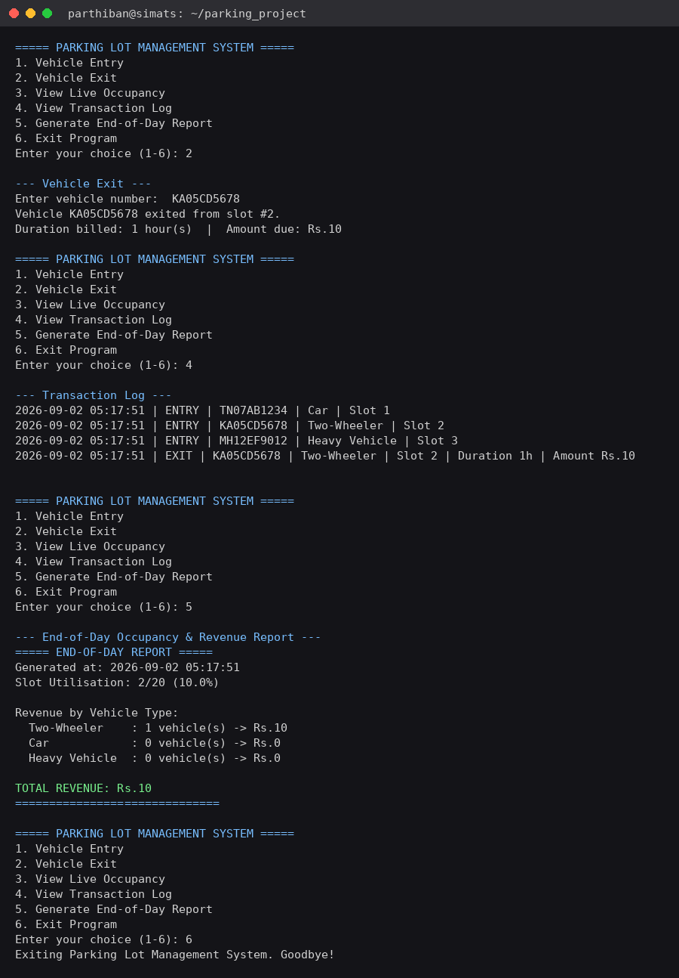
Figure 3: Vehicle exit with billing, transaction log read-back, and end-of-day report generation.

10. Results and Validation
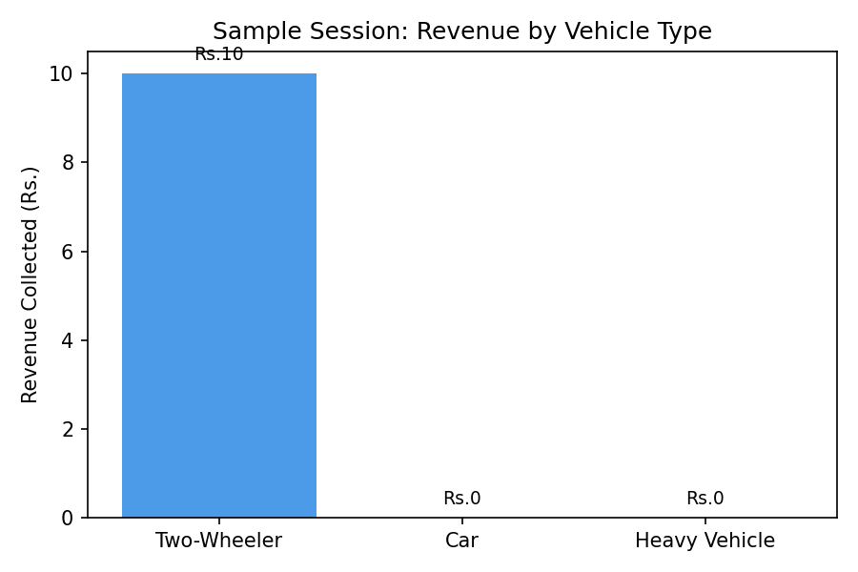
Figure 4: Revenue collected by vehicle type for the sample session in Figures 2–3.
Metric | Value (sample session)
Total slots in pool | 20
Vehicles registered | 3 (Car, Two-Wheeler, Heavy Vehicle)
Vehicles exited / billed | 1
Peak utilisation reached | 15% (3/20 slots)
Utilisation at report time | 10% (2/20 slots, after 1 exit)
Total revenue collected | Rs.10
Invalid entries rejected | 1 (bad format)
All 11 test cases in Section 8 passed, covering slot allocation ordering, capacity limits, three different billing scenarios (exact hour, partial-hour rounding, minimum-hour floor), input validation, and end-to-end log/report accuracy. The end-of-day report values were cross-checked by hand against the transaction log and matched exactly.

11. Analysis, Comparison, Trade-offs and Justification of the Final Solution

Design choices and trade-offs
- Dict + set for slots: a dict alone could represent occupancy (None vs vehicle_no), but pairing it with a set (occupied_slots) turns “is a slot free / is the lot full” checks into O(1) lookups instead of scanning all slots — a deliberate space-for-speed trade-off appropriate at this scale.
- Linear scan for nearest slot: allocate_slot() scans from slot 1 upward (O(n) worst case). For a 20-slot lot this is negligible; a min-heap of free slot numbers would reduce this to O(log n) and would be the natural upgrade if the slot pool grew very large.
- Flat text log vs a database: a plain append-only file satisfies the file-handling requirement and is trivially human-readable, but does not support concurrent writers or fast querying — acceptable for a single-operator console tool, a limitation for multi-terminal deployment.
- Round-up billing: charging any partial hour as a full hour is simpler and matches common commercial parking practice, at the cost of being less “fair” to short-stay customers than per-minute billing.

Why this solution over alternatives
An object-oriented design (Slot and Vehicle classes) was considered, but the functional module design was chosen because the assignment explicitly required demonstrating lists/dicts/tuples/sets and modules/packages as first-class course concepts — the functional approach keeps that mapping direct and easy to justify against the rubric.

12. Broader Considerations / SDG Relevance
SDG | Relevance to this project
SDG 9 – Industry, Innovation and Infrastructure | Digitises a manual, paper-based process into a reliable software system — a small-scale example of resilient infrastructure and innovation applied to urban commercial facilities.
SDG 11 – Sustainable Cities and Communities | Efficient slot allocation and real-time occupancy visibility reduce vehicle circling/search time in commercial parking, supporting smoother urban traffic flow.
SDG 12 – Responsible Consumption and Production | Accurate, automated billing and persistent digital logs reduce paper register usage and revenue leakage from manual/human error.

13. Conclusion, Limitations and Possible Improvements

Conclusion
The implemented Parking Lot Management System meets all stated functional requirements: menu-driven operation, nearest-slot allocation, format-validated vehicle entry, duration-based tariff billing, persistent file logging, modular code organisation, and end-of-day reporting. All 11 designed test cases passed.

Limitations
- No persistence of active (still-parked) vehicle_records across program restarts — only completed transactions survive via the log file, not the in-memory state.
- Single vehicle-number format supported; does not generalise to other countries' plate formats.
- No concurrency control — unsuitable for multiple simultaneous operator terminals.
- Nearest-slot search is linear; would not scale efficiently to very large slot pools (thousands of slots).

Possible Improvements
- Persist vehicle_records to a JSON/CSV file (or a lightweight database) so active sessions survive a restart.
- Replace the linear nearest-slot scan with a min-heap for O(log n) allocation at scale.
- Add zone-aware allocation (e.g. reserve certain slot ranges for heavy vehicles).
- Add a simple GUI (tkinter) on top of the existing slot_manager/billing modules without changing their logic.

14. Individual Contribution of Group Members
This assignment was completed individually by Parthiban, who was solely responsible for problem formulation, module design (slot_manager.py, billing.py), implementation of main.py, test-case design and execution, and report preparation. (If this is submitted as part of a group, replace this section with a per-member breakdown of the same tasks.)

15. References
- Python Software Foundation. Python 3 documentation — re, datetime, math modules. https://docs.python.org/3/
- Python Software Foundation. Python Tutorial — Modules and Packages. https://docs.python.org/3/tutorial/modules.html
- United Nations. The 17 Sustainable Development Goals. https://sdgs.un.org/goals
- Course materials: CSA08 – Python Programming, Department of CSE, SIMATS University.
- Tools used: Python 3.12 interpreter; Graphviz (flowchart generation); Matplotlib (results chart); GitHub (version control / submission).

